**HCI CAT 1 Answers**

**1.b) Explain in detail about Reasoning and problem solving?**

**Ans.1.b)**

**Reasoning**

**Reasoning is the process by which we use the knowledge we have to draw conclusions or infer something new about the domain of interest. There are a number of different Types of reasoning: deductive, inductive and abductive. We use each of these types of reasoning in everyday life, but they differ in significant ways.**

1. **Deductive reasoning**

**Deductive reasoning derives the logically necessary conclusion from the given premises.**

**For example:**

**If it is Friday, then she will go to work**

**It is Friday**

**Therefore, she will go to work.**

1. **Inductive reasoning**

**Induction is generalizing from cases we have seen to infer information about cases we have not seen. Induction is a useful process, which we use constantly in learning about our environment. We can never see all the elephants that have ever lived or will ever live, but we have certain knowledge about elephants which we are prepared to trust for all practical**

**purposes, which has largely been inferred by induction. Even if we saw an elephant without a trunk, we would be unlikely to move from our position that ‗All elephants have trunks‗, since we are better at using positive than negative evidence.**

1. **Abductive reasoning**

**The third type of reasoning is abduction. Abduction reasons from a fact to the action or state that caused it. This is the method we use to derive explanations for the events we observe. For example, suppose we know that Sam always drives too fast when she has been drinking. If we see Sam driving too fast we may infer that she has been drinking. Of course, this too is unreliable since there may be another reason why she is driving fast: she may have been called to an emergency.**

**Problem solving**

**Human problem solving is characterized by the ability to adapt the information we have to deal with new situations often solutions seem to be original and creative. There are a number of different views of how people solve problems. The Gestalt view that problem solving involves both reuse of knowledge and insight. This has been largely superseded but the questions it was trying to address remain and its influence can be seen in later research. In the 1970s by Newell and Simon, was the problem space theory, which takes the view that the mind is a limited information processor.**

**1.c) Describe five important differences between Short Term Memory and Long-Term Memory.**

**Ans.1.c)**

|  |  |  |
| --- | --- | --- |
| **Sr. No.** | **Short-Term Memory** | **Long-Term Memory** |
| **1** | **Temporary storage of information** | **Long-term storage of information** |
| **2..** | **Limited capacity** | **Huge, if not unlimited, capacity** |
| **3.** | **Rapid access time (around 70 ms)** | **Relatively slow access time (around a tenth of a second)** |
| **4.** | **Information decays rapidly (around 200 ms)** | **Forgetting occurs more slowly, if at all** |
| **5.** | **Used for temporary recall of information** | **Used for the long-term storage of information** |
| **6.** | **Holds information that is currently being processed** | **Holds factual information, experiential knowledge, procedural rules, etc.** |
| **7.** | **Filtered by attention** | **Information is placed there through rehearsal** |
| **8.** | **Can be measured by sequence length or free recall** | **Can be measured by long-term recall** |

**2.b) Define interaction. Explain the Models — frameworks of it?**

**Ans.2.b)**

**Interaction involves at least two participants: the user and the system. The interface must therefore effectively translate between them to allow the interaction to be successful. This translation can fail at a number of points and for a number of reasons. The use of models of interaction can help us to understand exactly what is going on in the interaction and identify the likely root of difficulties. They also provide us with a framework to compare different interaction styles and to consider interaction problems.**

**The models and frameworks of interaction provide a way to understand and analyze the process of interaction between a user and a system. They help us identify the different components involved in the interaction and how they interact with each other.**

**One commonly used framework is the interaction framework, which consists of four main components: the System, the User, the Input, and the Output. Each component has its own language. The User has a task language, the System has a core language, and the Input and Output components together form the Interface.**

**The interaction framework also includes the concept of translations between the components. The User articulates their task using their task language, which is then translated into the System's core language. The System performs the necessary operations based on the translated task, resulting in a new state. This new state is then translated into concepts or features of the Output, which the User observes and evaluates.**

**Another important model is the framework for human-computer interaction (HCI). This framework considers the user's immediate context, including input and output, as well as the social and organizational context. It encompasses areas such as dialog design, interface styles, and presentation and screen design. Ergonomics, which focuses on the physical characteristics of the interaction, is also a part of HCI.**

**These models and frameworks help designers and researchers understand the interaction process, identify potential issues, and design more effective and user-friendly interactive systems.**

**2.c) Briefly discuss about the types of memory in detail.**

**Ans.2.c)**

**There are three types of memory or memory function: sensory memory, short-term memory or working memory, and long-term memory.**

**1. Sensory Memory: This memory acts as a buffer for stimuli received through the senses. It includes iconic memory for visual stimuli, echoic memory for aural stimuli, and haptic memory for touch. Sensory memories are constantly overwritten by new information.**

**2. Short-term Memory or Working Memory: This memory holds currently active information and allows us to process and manipulate it. It has a limited capacity and a relatively fast access time. Short-term memory is where we temporarily store information before it is either forgotten or transferred to long-term memory.**

**3. Long-term Memory: This memory is intended for the long-term storage of information. It has a huge capacity and a relatively slow access time. Long-term memory is where we store factual information, experiential knowledge, procedural rules of behavior, and everything we "know." It has a slower rate of forgetting compared to short-term memory.**

**Long-term memory can be further divided into two types:**

**- Episodic Memory: This represents our memory of events and experiences in a serial form. It allows us to reconstruct past events and experiences.**

**- Semantic Memory: This is a structured record of facts, concepts, and skills that we have acquired. It is derived from our episodic memory and contains our knowledge and understanding of the world.**

**3.b) Explain in detail about process of design with suitable examples.**

**Ans.3.b)**

**The Process of Design**

**A system has been designed and built, and only when it proves unusable do they think to ask how to do it right! In other companies usability is seen as equivalent to testing – checking whether people can use it and fixing problems, rather than making sure they can from the beginning. In the best companies, however, usability is designed in from the start.**

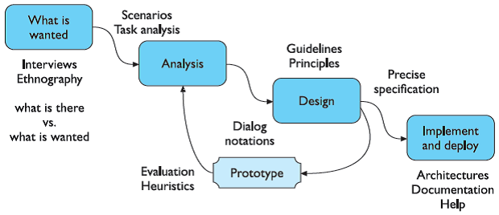

Figure: Interaction design process

**Requirements –**

**What is wanted? The first stage is establishing what exactly is needed. As a precursor to this it is usually necessary to find out what is currently happening.**

**Analysis:**

**The results of observation and interview need to be ordered in some way to bring out key issues and communicate with later stages of design.**

**Design:**

**Well, this is all about design, but there is a central stage when you move from what you want, to how to do it. There are numerous rules, guidelines and design principles that can be used to help.**

**Iteration and prototyping:**

**Humans are complex and we cannot expect to get designs right first time. We therefore need to evaluate a design to see how well it works and where there can be improvements.**

**Implementation and deployment:-**

**Finally, when we are happy with our design, we need to create it and deploy it. This will involve writing code, perhaps making hardware, writing documentation and manuals – everything that goes into a real system that can be given to others.**

**3.c) Briefly discuss about the three main approaches to prototyping.**

**Ans.3.c)**

**. There are three main approaches to prototyping:**

1. **Throw-away**

**The prototype is built and tested. The design knowledge gained from this exercise is used to build the final product, but the actual prototype is discarded. Figure depicts the procedure in using throw-away prototypes to arrive at a final requirements specification in order for the rest of the design process to proceed.**

1. **Incremental**

**The final product is built as separate components, one at a time. There is one overall design for the final system, but it is partitioned into independent and smaller components. The final product is then released as a series of products, each subsequent release including one more component.**

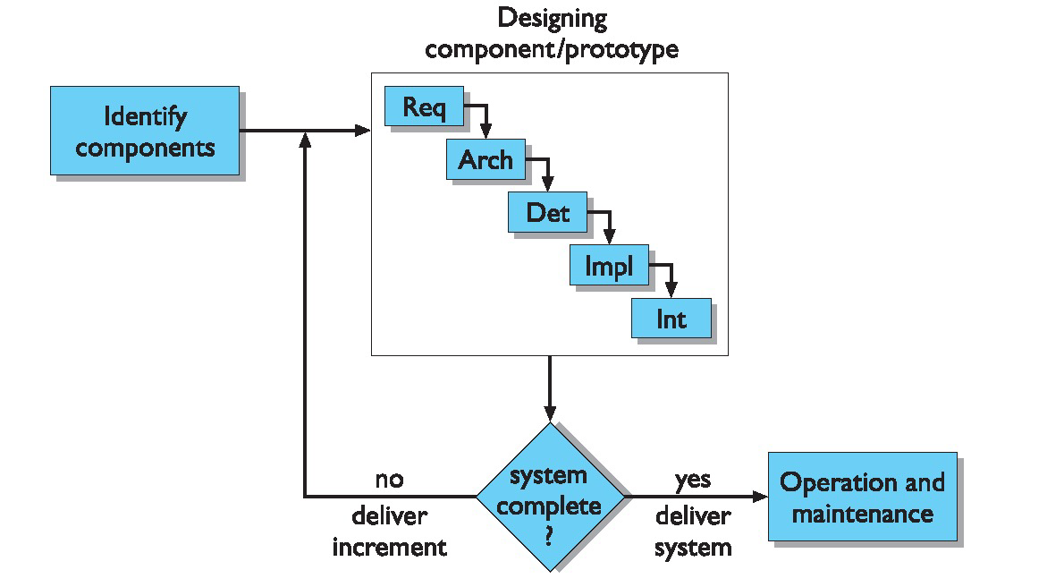

Figure: Incremental prototyping within the life cycle

1. **Evolutionary**

**Here the prototype is not discarded and serves as the basis for the next iteration of design. In this case, the actual system is seen as evolving from a very limited initial version to its final release. It also fits in well with the modifications which must be made to the system that arise during the operation and maintenance activity in the life cycle.**

**4.b) Explain the software life cycle process in a HCI software process.**

**Ans.4.b)**

**the software life cycle refers to the stages involved in the development of a software product with a focus on human-computer interaction. The software life cycle process in HCI software development typically includes the following stages:**

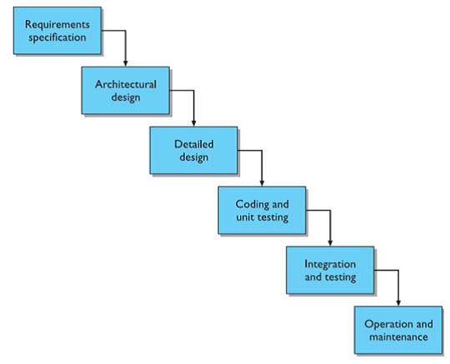

1. **Requirements Gathering:**

**This stage involves understanding the needs and requirements of the users and stakeholders. It includes activities such as user research, interviews, and observations to gather information about user preferences, goals, and tasks.**

1. **Design:**

**In this stage, the design team creates the user interface and interaction design based on the gathered requirements. It includes creating wireframes, prototypes, and visual designs to define the structure, layout, and functionality of the software.**

1. **Implementation:**

**The design is then translated into actual code during the implementation stage. The development team writes the software code, integrates different components, and ensures that the software functions as intended.**

1. **Integration and Testing:**

**Once the individual components are implemented, they are integrated into a cohesive system. Testing is performed to ensure that the software behaves correctly, meets the requirements, and provides a satisfactory user experience. This stage may also involve acceptance testing with the customers to ensure that the system meets their needs.**

1. **Maintenance:**

**After the software is released, it enters the maintenance stage. This stage involves ongoing support, bug fixes, updates, and enhancements based on user feedback and changing requirements. Maintenance continues until a new version of the software is released or the product is phased out.**

**It is important to note that the software life cycle in HCI software development is iterative and never complete. The design process involves continuous refinement and improvement based on user feedback and evaluation.**

**4.c) With a neat sketch, describe about** **Interaction design process and golden rule of Design.**

**Ans.4.c)**

**Interaction Design Process**

**The interaction design process involves several stages and is iterative in nature. It begins with understanding the needs and context of the users. This includes identifying who the users are, observing and talking to them to gather information about their preferences and requirements.**

**Once the user needs are established, the next stage is analysis. This involves organizing and ordering the information gathered from the users to identify key issues and communicate them effectively to the later stages of the design process.**

**After analysis, the requirements for the interactive system are determined. This stage involves establishing what exactly is needed and may require an understanding of the current system or processes in place.**

**Once the requirements are defined, the design phase begins. This involves creating design solutions that address the identified user needs and requirements. Storyboards or graphical representations of the interface at different points in the interaction can be used to evaluate and gather user impressions of the design.**

**The design process is iterative, meaning that it involves evaluating and modifying the design based on user feedback. This iterative approach allows for continuous improvement and refinement of the design until the best possible solution is achieved within the given project time.**

**Overall, the interaction design process involves understanding user needs, analyzing requirements, designing solutions, and iterating on the design based on user feedback.**

**Golden Rule of Design**

**The golden rule of design in the interaction design process is to create a system that is simple and intuitive to use, regardless of the user's knowledge, experience, language, or level of concentration. The design should support the user's expectations and accommodate different language and literacy skills. It should not be unnecessarily complex and should be organized to facilitate access to the most important areas. It should provide prompting and feedback as much as possible.**

**5.b) What is meant by GOMS? Give an example.**

**Ans.5.b)**

**The GOMS model of Card, Moran and Newell is an acronym for Goals, Operators, Methods and Selection**

**Goals**

**These are the user’s goals, describing what the user wants to achieve. GOMS the goals are taken to represent a ‗memory point‗ for the user, from which he can evaluate what should be done and to which he may return should any errors occur.**

**Operators**

**These are the lowest level of analysis. They are the basic actions that the user must perform in order to use the system. They may affect the system (for example, press the‗X‗ key) or only the user’s mental state (for example, read the dialog box). There is still a degree of flexibility about the granularity of operators; we may take the command level issue the SELECT command‗ or be more primitive: ‗move mouse to menu bar, press center mouse button.**

**Methods**

**There are typically several ways in which a goal can be split into subgoals. For instance, in a certain window manager a currently selected window can be closed to an icon either by selecting the ‗CLOSE‗ option from a pop-up menu, or by hitting the ‗L7‗ function key. In GOMS these two goal decompositions are referred to as methods, so we have the CLOSE-METHOD and the L7-METHOD.**

**Selection**

**From the above snippet we see the use of the word select where the choice of methods arises. GOMS does not leave this as a random choice but attempts to predict which methods will be used. This typically depends both on the particular user and on the state of the system and details about the goals.**

**Rule 1: Use the CLOSE-METHOD unless another rule applies.**

**Rule 2: If the application is ‗blocks‗ use the L7-METHOD.**

**Example**

* **Goals (G) as a task to do e.g., “Send e-mail”.**
* **Operators (O) as all actions needed to achieve the goal e.g., “amount of mouse clicks to send e-mail”.**
* **Methods (M) as a group of operators e.g., “move mouse to send button, click on the button”.**
* **Selection (S) as a user decision approach e.g., “move mouse to send button, click on the button” or “move mouse to send button, click ENTER”.**

**5.c) Describe cognitive model and its techniques.**

**Ans.5.c)**

**Cognitive complexity refers to the number of mental structures an individual uses, how abstract they are and how they interact to shape his discernment, or an individual difference variable linked with a wide range of communication skills and associated abilities.**

**Individuals with high cognitive complexity have the capacity to analyze a situation to discern various constituent elements and explore connections and possible relationships among the elements. These individuals think in a multidimensional way.**

**The assumption of the complexity theory is that the more an event can be differentiated, and parts considered in novel relationships, the more sophisticated the response and successful the solution. Whereas less complex individuals can be trained to understand a complicated set of detailed differentiations for a specific context, highly complex individuals are highly flexible in creating distinctions in new situations.**

**Individuals with high cognitive complexity are open to new information, attracted to other individuals of high complexity, highly flexibility, socially influential, problem solvers, strategic planners, highly creative, effective communicators, and generally good leaders.**

**Some techniques used in cognitive model include:**

1. **Hierarchical models: These models represent a user's task and goal structure by breaking down complex tasks into smaller subgoals.**
2. **Linguistic models: These models represent the grammar and language used in the interaction between the user and the system.**
3. **Physical and device models: These models represent human motor skills and the interaction with physical devices, such as keyboards, mice, and touchscreens.**
4. **Cognitive architectures: These underlying frameworks provide a structure for cognitive models and represent the cognitive processes involved in human information processing.**
5. **Problem space models: These models represent a problem-solving process by defining a set of states and operations that can be performed on those states to achieve a desired goal.**

**6.b) What are the organizational issues present in socio organization?**

**Ans.6.b)**

**Organizational issues present in socio-organizational are:**

1. **Conflict and power relationships:**

**Systems may not consider the existing conflicts and power dynamics within an organization, which can affect the acceptance of technology by users.**

1. **Unequal distribution of work:**

**In some cases, those who benefit from the technology may not be the ones responsible for doing the actual work. This can create dissatisfaction and resistance among employees.**

1. **Unequal adoption of systems:**

**Not everyone within an organization may use or have access to the systems being implemented. This can lead to disparities in information sharing and collaboration.**

1. **Changing power structures:**

**The introduction of new technology can disrupt existing power structures and information flows within an organization. This can create resistance and subversion of the system by individuals who feel their control or sources of information are being compromised.**

1. **Cooperation and conflict:**

**Organizations consist of individuals and groups with conflicting goals. Systems that ignore these conflicts and assume complete cooperation are likely to fail.**

1. **Formal and informal networks:**

**Informal networks within an organization, which support both social and functional contacts, can influence information transfer and power relationships. These networks may not align with the formal organizational structure.**

**6.c) Explain in detail about goal and task hierarchies.**

**Ans.6.c)**

**Goal and task hierarchies are cognitive models that represent the structure and organization of user goals and tasks in interactive systems. These hierarchies break down complex goals into smaller, more manageable subgoals, creating a hierarchical structure.**

**In a goal hierarchy, the main goal is divided into subgoals, which can further be divided into more specific subgoals until a desired level of detail is reached. For example, if the main goal is to "produce a report," subgoals could include "gather data," "create tables and histograms," and "write descriptive material." Each of these subgoals can be further decomposed into more specific subgoals. The hierarchy continues until the tasks reach a level where they can be easily performed by the user, such as individual hand and eye movements.**

**Task hierarchies provide a more detailed breakdown of the steps required to achieve each subgoal in the goal hierarchy. They represent the sequence of actions and operations that need to be performed to accomplish a specific task. Task hierarchies can be represented using methods like GOMS (Goals, Operators, Methods, and Selection rules) or keystroke-level models.**

**The purpose of goal and task hierarchies is to provide a structured and organized approach to designing interactive systems. By breaking down complex goals into smaller, more manageable tasks, designers can better understand user requirements and design interfaces that support efficient and effective user interactions.**

**Overall, goal and task hierarchies are important cognitive models that help in understanding and representing the structure of user goals and tasks in interactive systems, facilitating the design and development of user-friendly interfaces.**